Blue Horizon Travel & Yacht Charters presents…
Southern Charm
October 10 – 16, 2021

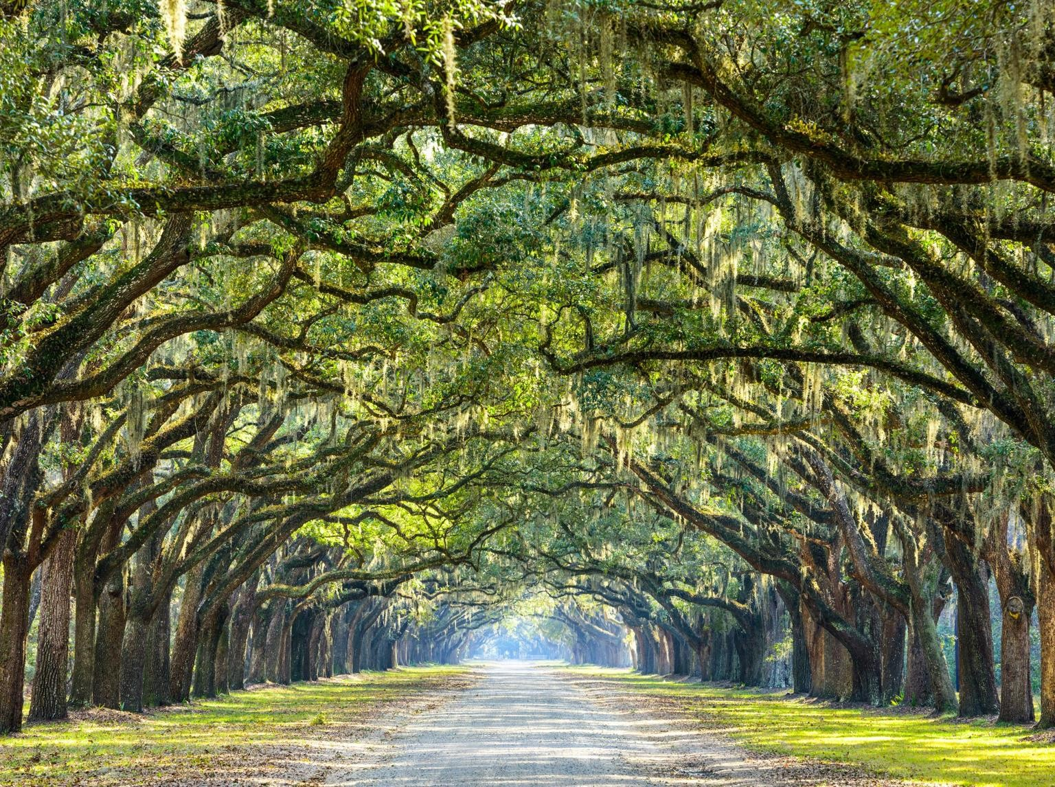

Featuring Charleston, Savannah & Jekyll Island including Airfare
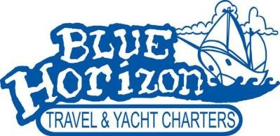
For more information contact Linda Meadors
Blue Horizon Travel & Yacht Charters 309-235-5806
Linda@bluehorizon.net www.bluehorizon.net

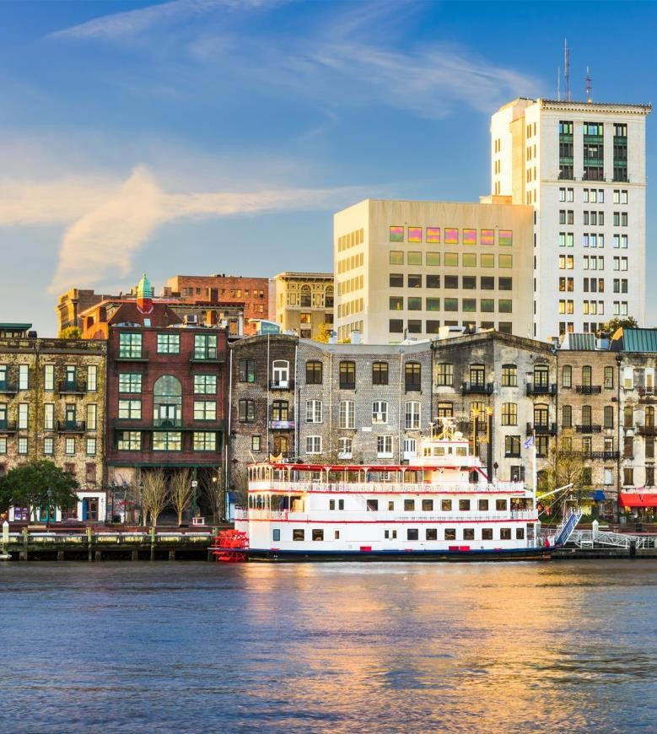
7 Days ● 10 Meals: 6 Breakfasts, 1 Lunch, 3 Dinners

HIGHLIGHTS… Historic Charleston, Choice on Tour, Boone Hall Plantation & Gardens, Savannah, St. Simons Island, Jekyll Island

ITINERARY AT A GLANCE
Days 1, 2 Renaissance Charleston Historic District Hotel, Charleston,South Carolina
Days 3, 4 Doubletree Historic Savannah, Savannah,Georgia Days 5, 6 Jekyll Island Club, Jekyll Island, Georgia
On some dates alternate hotels may be used.

Collette’s Flagship: Collette’s tours open the door to a world of amazing destinations. Marvel at must-see sights, sample regional cuisine, stay in centrally located hotels and connect with new and captivating cultures. These itineraries offer an inspiring and easy way to experience the world, where an expert guide takes care of all the details.

Includes Round Trip Air from Chicago or Other Major Gateways

Real ID or Valid Passport Required
Day 1: Sunday, October 10, 2021 Charleston, South Carolina - Tour Begins Experience warm Southern hospitality in America’s southeast. Come to know its rich history and deep traditions on this tour highlighted by stays in Charleston, Savannah and Jekyll Island. Begin your journey in Charleston, a city that has defied all odds. Charleston has survived the Civil War, major fires, an earthquake, and hurricanes
– and still exudes elegance, charm, and grace.
Day 2: Monday, October 11, 2021 Charleston Decide how to see the city because it’s your choice! Stroll through Charleston’s historic center with a local guide, exploring hidden alleys and quaint areas that are only accessible by foot -OR- take a harbor cruise to Fort Sumter, where the first fired shots of the Civil War were fired, and chat with a ranger before exploring on your own. Later, make your way to bustling City Market, one of the country’s oldest public markets and the central hub for Gullah sweetgrass basketry – an intricate handicraft of African origin. Explore Boone Hall Plantation and Gardens, where you’ll experience Southern living as you come to know one of America's oldest plantations. This evening, join your fellow travelers for a welcome dinner at a local restaurant. (B, D)
Day 3: Tuesday, October 12, 2021 Charleston - Savannah, Georgia Discover beautiful Charleston on a horse-drawn carriage ride through the Historic District. Settle into a relaxed pace of life as you absorb the timeless charm of this enchanting city. Your carriage driver will make the stories of Charleston come alive with commentary throughout your journey. Complete your Charleston experience with lunch at a local restaurant. Then, travel down the coast through South Carolina’s Low Country to historic Savannah. This evening, spend some time exploring Factors Walk and River Street, where old cotton warehouses have been converted into trendy shops, taverns and restaurants. (B, L)
Day 4: Wednesday, October 13, 2021 Savannah Take in the ambiance of the “Old South” with a trolley tour highlighting Savannah's sprawling Historic District. Lively, informative commentary brings the city to life as you travel along the
cobblestone-paved streets and beneath moss-draped oaks. Allow the stately mansions, beautiful squares and romantic riverfront promenades to capture your heart. The rest of the afternoon is yours to do as you wish. Perhaps you will join an optional walking tour and lunch to get a closer look at some of Savannah’s elegant gates and secret gardens. Tonight, gather at a popular local restaurant on Savannah’s famous River Street for a cooking demonstration and dinner showcasing regional specialties. (B, D)
Day 5: Thursday, October 14, 2021 Savannah - St. Simons Island - Jekyll Island Journey to Georgia’s legendary Gold Coast and visit the quaint St. Simons Island. See its stunning, 106-foot tall lighthouse before stepping into the past at the Museum of Coastal History. Enjoy time to explore the area on your own, meandering along the unique shops and restaurants in the village. Continue on to the exclusive Jekyll Island Club hotel, your home for the next two nights. (B)
Day 6: Friday, October 15, 2021 Jekyll Island Situated grandly in the middle of the Golden Isles, Jekyll Island was once the beloved vacation spot for prominent families, including the Rockefellers, Vanderbilts and J.P. Morgan. With a morning at leisure, enjoy the old-world atmosphere of this iconic resort. Gather for a tram ride that brings you on a tour of the island and the Jekyll Island Historic Landmark District – one of the nation’s largest restoration projects. Tonight, join your fellow travelers for a farewell dinner at the Jekyll Island Club hotel. (B, D)

Day 7: Saturday, October 16, 2021 Jekyll Island - Jacksonville, Florida
- Tour Ends As your tour draws to a close, leave for home with memories of a trip well-traveled. Your days spent experiencing true southern charm and gracious hospitality will stay dear to your heart for years to come. (B)

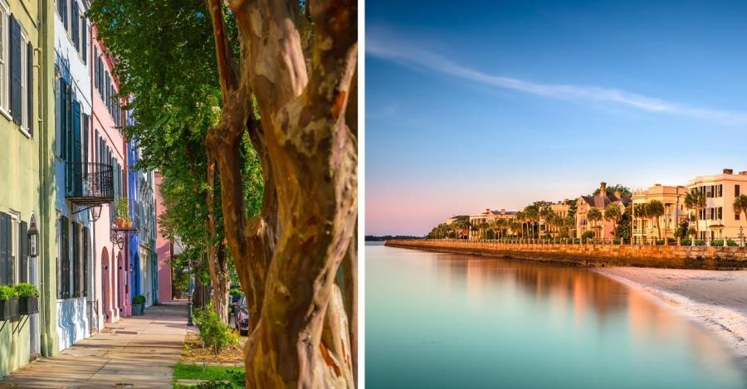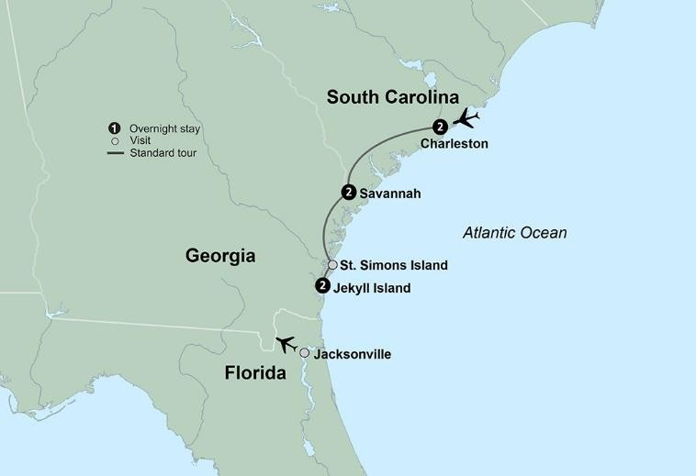
Per Person Rates*:
Double $2,999; Single $3,699; Triple $2,969
Included in Price: Round Trip Transportation from Moline to O'Hare Airport, Round Trip Air from O'Hare Intl Airport, Air Taxes and Fees/Surcharges, Hotel Transfers
Not included in price: Cancellation Waiver and Insurance of $299 per person, Blue Horizon processing fee of $45 per person
- All Rates are Per Person and are subject to change
IMPORTANT CONDITIONS: Your price is subject to increase prior to the time you make full payment. Your price is not subject to increase after you make full payment, except for charges resulting from increases in government-imposed taxes or fees. Once deposited, you have 7 days to send us written consumer consent or withdraw consent and receive a full refund. (See registration form for consent.)
Single accommodations are limited and are available on a first come, first served

PLEASE NOTE:
IDENTIFICATION
Travel within USA
For travel completed by September 30, 2021, all airlines will ask for identification when you check in. It is recommended that you carry a passport if you have one. A driver's license (with a photo I.D.) is also acceptable for domestic flights.
Effective for travel October 1, 2021 forward, the REAL ID Act standards for identification while travelling will be in effect. This means a standard issued driver’s license used as a form of identification will no longer be accepted for domestic air travel within the United States. Instead, a Real ID compliant form of identification must be presented both at the time of booking air travel with Collette and upon checking in at the airport to board any flight. Any fees associated with changing a reservation resulting from a non-compliant identification will be the responsibility of the guest. For more information on Real ID, please visit the Department of Homeland Security website: https://www.dhs.gov/real-id
Due to flight schedules, a pre-night in Charleston may be required (at an additional cost). Please inquire at the time of booking.
To complete your tour, we include roundtrip airport-to-hotel transfers when purchasing our airfare with your tour. If you have arranged for your own air, we are pleased to provide you the option of purchasing these transfers. Please note that all transfers will leave at pre-scheduled times.
basis.
Due to tour scheduling, return flights should be booked after 12:00 p.m.
The overall activity level of this tour is a level 2. This means you like a balanced approach to travel. You feel confident walking at least 30-45 minutes at a time over a variety of terrains – from cobblestone streets to easy pathways; a couple of hills or a few flights of stairs. You’re comfortable walking a few city blocks at a time, but need some time to unwind and relax.
Please be advised many airlines do not provide advance seat assignments until check-in at the airport. Advance seating will be subject to the airline's terms and conditions.
Economy air rate and schedule are applicable for groups of 10 or more traveling on the same flights and dates.
A deposit of $600 per person is due upon reservation. Reservations are made on a first come, first served basis. Reservations made after the deposit due date of May 01, 2021 are based upon availability. Final payment due by July 30, 2021. Deposits are refundable up until May 01, 2021.
CST#2006766-20 UBN#601220855 Nevada Sellers of Travel Registration No. 2003- 0279

Blue Horizon Passenger Agreement must accompany registration

Experience It! Jekyll Island
Situated in the Atlantic Ocean off the Georgia coast lies Jekyll Island, the smallest of Georgia’s barrier islands. In 1886, Jekyll Island was transformed from a quiet little island into an exclusive winter retreat for America’s rich and famous and became known as the Jekyll Island Club. The Rockefellers, Morgans and Pulitzers were a few of the families that vacationed here in its heyday. Today, the island is owned by the State of Georgia which has implemented restrictions on development that leaves one third of the island to nature preserves. Its open spaces, pristine beaches, quaint shopping and dining district, and a fascinating historical museum have made this island flourish over the recent decades.
For more information visit https://gateway.gocollette.com/link/1050588

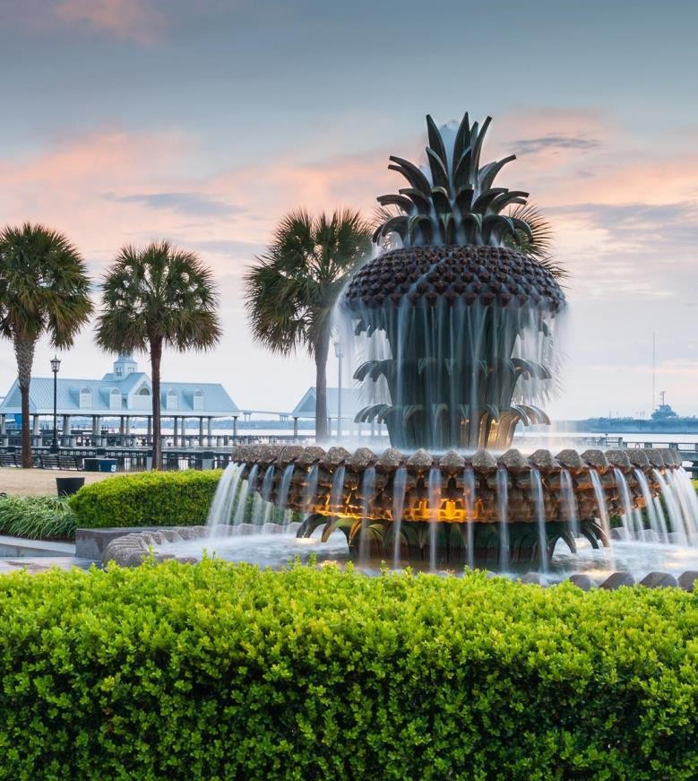
.

NOTES:

For important reservation information visit https://gateway.gocollette.com/link/1050588.
You can also find this information on your tour documents.

