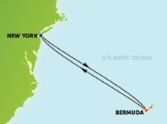
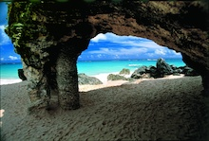

Please join Joel and Bonnie Newman on the Norwegian Cruise Line Escape sailing from New York, New York on May 26, 2019.
Enjoy a relaxing cruise with three full days at sea and three days to explore the wonders of Bermuda!
Ask about the current Norwegian promotions!

Sun New York, New York

Mon At Sea

Tue At Sea

Wed Royal Naval Dockyard, Bermuda

Thu Royal Naval Dockyard, Bermuda

Fri Royal Naval Dockyard, Bermuda

Sat At Sea

Sun New York, New York

