Blue Horizon Travel and Yacht Charters Registration Form
CANADIAN ROCKIES TOUR & ROCKY MOUNTAINEER RAIL
JULY 13-24, 2019
Optional Alaska Cruise
JULY 13-24, 2019
Passenger information (1st Traveler)
Name must be exactly as it appears on your passport.
First Name:___________________________________
Middle Name(s):_______________________________
Last Name(S):_________________________________
Gender:_________ Passport #:___________________
Passport Expiration Date:________________________
Passport Authority:_____________________________
Date of Birth:__________________________________
Departure City:_________________________________
Medical or Physical Needs:_______________________
Nickname:____________________________________
Celebrations during travel:_______________________

Passenger information (2nd Traveler)
Name must be exactly as it appears on your passport.
First Name:___________________________________
Middle Name(s):_______________________________
Last Name(S):_________________________________
Gender:_________ Passport #:___________________
Passport Expiration Date:________________________
Passport Authority:_____________________________
Date of Birth:__________________________________
Departure City:_________________________________
Medical or Physical Needs:_______________________
Nickname:____________________________________
Celebrations during travel:_______________________

Address:_____________________________________________________City:__________________________
State:______ Zip Code:____________ Phone:_______________________ Cell Phone:____________________
Email:___________________________________________
Emergency Contact Name:_______________________________________Phone:_______________________
All rates are per person (pp), are based on double occupancy. A deposit of $250.00pp + deposit will confirm your space.
CANADIAN ROCKIES TOUR & ROCKY MOUNTAINEER RAIL Land package; $5935.00 pp $_________________
TAXES; $134.00 pp $_________________
AIRFARE TBA $_________________
INSURANCE due with deposit; 289.00 pp $_________________
DEPOSIT TOTAL $_________________
BALANCE due March 1, 2019 $_________________
- Yes, I am interested in the optional Alaskan Cruise Upgrade to GoldLeaf Rocky dome + $620 pp

Check number enclosed ____________ AX/MC/Visa/DS _____ Credit Card Number______________________________________

Expiration date__________ Security code_______ Name on card _____________________________________________________

Signature ___________________________________________
Cancellations: A $50.00 per person administrative fee will be retained by Blue Horizon Travel for all cancellations.
Single and triple rates available upon request. Please review the Globus terms and conditions
Passports are required for travel and must be valid for 6 months from the return date.
Send payment to Blue Horizon Travel & Yacht Charters, 12570 US HWY 150, Orion, IL 61273
For more information contact Linda Meadors at 309-912-4888 or Linda@bluehorizon.net
Bonnie Newman at 309-737-0059 or email Bonnie@bluehorizon.net

Add an ALASKA CRUISE to your CANADIAN ROCKIES tour!
EARLY BOOKING DISCOUNT SAVE 10%

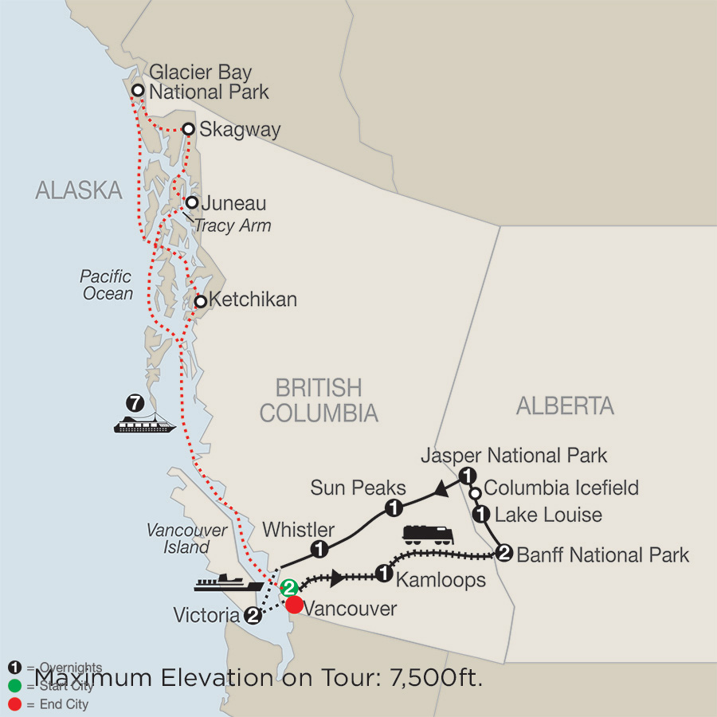
Add a 7 night Alaskan Cruise from $1580 pp
(pricing without any promotional offers)
Holland American Volendam July 24-31, 2019

Interior cabin- double occupancy $949.00
Port fees 504.00
Taxes 127.66
Total $1580.66 per person double occupancy

Upgrade to Ocean view + $464.00 pp
Upgrade to Verandah + $1737.00 pp

